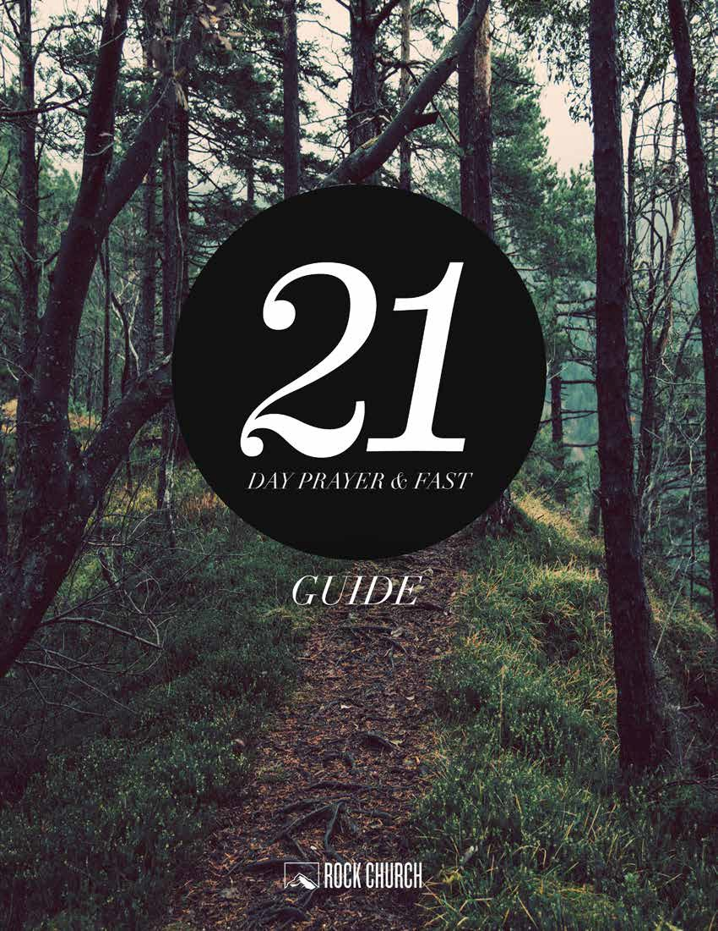

It’s one thing to know about God— it’s a different thing to be known by God. Prayer and fasting are powerful ways to prepare to receive His presence, and all that He has planned for your life, as well as grow deeper in your walk with Him as you proclaim, More of you and less of me.
Ask yourself, What am I allowing to come between me and God’s presence? Imagine the blessings He has for you when you prepare your heart and surrender it all to Him.
Join Pastor Miles as he encourages you to devote yourself intentionally to seeking God and His will for your life during the 21-Day Prayer & Fast journey.

WHAT IS FASTING?
Fasting is to voluntarily abstain from eating/drinking for an extended period of time. “Eating” and “drinking” can repre- sent anything that is holding you back. What do you “consume” in terms of social food, intellectual food, spiritual food, and emotional food? Are these things distracting you from your relationship with God?
Are you relying on things that have nothing to do with God to get you through your day? You may not even realize you have an addiction. For example, if you “have to have” coffee every day, and you are not willing to give it up, you are addicted. Maybe your fast needs to just be about coffee. Ask God and He will show you.
Everyone doing a physical fast should consult a physician first. If you have medical issues, consider fasting TV or me- dia. The point is that there is something God wants you to separate yourself from for three weeks so that you can see Him more clearly. Don’t cheat yourself by removing yourself from the fast entirely.

FASTING GOAL: A PERSONAL ENCOUNTER WITH THE LIVING GOD
“He must increase and [we] must decrease.” - John 3:30 “Be ye holy, for I am holy.” - 1 Peter 1:16
You may experience many benefits from fasting (cleansing your body, breaking addictions, etc.), but the goal of fasting is to experience God. Right now your life may be all about you, what you want, and when you want it. Imagine if you separate yourself from your perceived needs (such as food)…you may see that life is all about Him.

Other examples of biblical fasting
Special revelation - Exodus 34:27-28 In times of war - Judges 20:26 Courage and wisdom - Esther 4:3,16
In times of grief - Nehemiah 1:4, 2 Samuel 1:12, Samuel 31:13, 1 Chronicles 10:12
Spiritual recuperation - 1 Kings 19:1-9 Mourning - Daniel 10:1-3
Repentance - Jonah 3:5, Daniel 6:18 Ministry preparation - Matthew 4:2 Spiritual power - Mark 9:29
Ministry commissioning - Acts 14:23
Set aside self for holiness - 1 Corinthians 7:5
Spiritual discipline - 1 Corinthians 11:24-28 (Paul “fasted often”)

FASTING PREPARATION

Prepare your heart:
In 2 Chronicles 7:14, God appears to Solomon and explains that if His people are going through a hard time, they should seek Him and follow His ways. Then, He will hear their prayers and heal them.
Be willing to hear what God says needs to change, and be willing to change. Don’t continue to sin. What are the paths He wants you to walk? How much does He want you to pray and read His Word? Tell God that you surrender your life to Him and that you want more of Him and His way.

Prepare your motives:
Ephesians 1:3 says that there are spiritual blessings assigned to us. We can never exhaust them! Who knows what God wants to give you or show you? Maybe He wants to bestow gifts such as wisdom, anointing, prayer power, healing power, teaching power, joy, or encouragement. When you eliminate things that are keeping you from focusing on God, He is able to show you things about your life that you never knew.

Prepare your body:
If you decide to eat only fruits and vegetables for your fast, it will result in cleansing of your physical body. You may feel sick as your body detoxes, but you’ll make it! This isn’t a mind game to see if you can survive eating less or not watch- ing ESPN, but about experiencing God. Some people ask, “What does not eating have to do with my relationship with God?” Pastor Miles’ response is, “Stop eating and find out.”

Prepare your schedule:
Decide where you will meet with God, what and when you will eat, and how you will spend your time differently. Re- member, the fast is about communing with God, so don’t fill your time with distractions that will keep you from feeling hungry. Create a plan and commit to spending more time with the Lord.

Fasting Guidelines:
- Explain to your family in advance what you are doing.
- Request privacy from those find out what you are doing.
- Ask them not to discuss it with you until your fast is over.
- Never complain or brag about your fast, and avoid talking about it.
- Establish an accountability partner for prayer & encouragement.
- Stay away from negative people.
- Spend as much time as possible alone in solitude and prayer.
- Acknowledge that your flesh cannot be trained, but must be crucified.
- Journal as you pray and meet with the Lord. Write down the miracles God does in your life!

TYPES OF FASTS

Complete Fast
- Drinking only liquids, typically water and/or light juices.
- Broth or soup may be included as options.

Selective Fast
- Removing certain elements from your diet.
- The Daniel Fast - abstaining from meat, sweets, or bread; drink water and juice, and eat a variety of fruits and vegetables.

Partial Fast (a.k.a. The Jewish Fast)
- Abstaining from eating any type of food in the morning and afternoon.
- Fast during specific times of the day, e.g. 6AM-3PM, or from sunup to sundown.

Soul Fast
- Common for: anyone new to fasting food; those with health issues that prevent them from fasting food; those wanting to refocus specific areas of life that are out of balance.
- Suggestions: abstain from engaging in social media, shopping, watching television, etc.

ENDURING YOUR FAST

To Eat or Not To Eat is Not The Question
As you continue to fast, you will realize that you don’t experience hunger pains as often as you thought you would. Without a preoccupation with food, you will be surprised at your ability to be sustained for a number of days without eating food and how you will take advantage of your time to seek Jesus more diligently. There is no magic in simply missing meals in the name of spirituality. The important thing to remember is to hear God speak and obey what you hear.

Prayer Life During The Fast
There is a question you will need to answer. When you are fasting, will you seek Him, give Him a listening ear and the quality time He deserves? He will constantly separate you from dependence on the world. Consequently, your time alone with Him may become more frequent than you originally planned, and needless to say, your prayer life will greatly improve.

How appropriate that Jesus and Moses spent extensive time in the desert alone with God. It is ironic that the Hebrew name for desert is madbar, meaning “to speak.” You will hear His voice throughout the day in a powerful way. Wisdom will cry out to you in the streets. As the stars in heaven declare the glory of God, so every corner will reveal to your willing soul the mysteries of His Kingdom that have been withheld from the rulers of this age (Proverbs 8:1-3, Psalm 19, and 1 Corinthians 2:7). You will hear Him when you are driving, talking on the phone, or counseling a friend. Expect to hear Him loud and clear.

Fighting Doubt and Fighting The Good Fight
During your fast, one of your biggest enemies will be your mind and your memory. Your mind and emotions will constantly work together to bring order to your world, order according to what you have been taught order to be. Eating at certain times each day has been part of your life training. Fasting will make no sense to your mind.

In Matthew 14:22-32, when Peter was walking on the water, he found himself in the middle of a miracle, something that did not make sense to his mind. When Peter’s mind revealed to him the supernatural nature of what he was doing, it convinced him that it was impossible, based on what his mind knew to be normal. Consequently, Peter sank, believing logically what his mind told him, rather than what the Spirit convinced him to believe by faith.

There will be times that your mind will realize how far out on a limb your faith has taken you and you will be faced with a decision: Do you give up or keep moving forward? Galatians 5:24 tells us that the flesh is at war against the Spirit. It cannot be trained or negotiated with. The flesh must die. It must be crucified. Always remember, faith goes all the way. God has not given you the Spirit of fear but one of Sonship, by which we call Abba Father (Romans 8:15).

When you feel as though you want to give up, you must ask yourself a few questions. Is the pain you are experiencing worth the prize you are pursuing? If you do give up, where and to what will you go back to? In John 6:66, the disciples were asked by Jesus if they wanted to go back to their old lifestyle. Peter said, “Lord, to whom shall we go? You have the words of life.”

Social Tensions
A frequently asked question about fasting is: “Should you tell people that you are fasting?” Since fasting is a discipline of self-denial and consecration unto the Lord, constant discussion about it will be a distraction. People will bombard you with countless questions about your health, offer you suggestions about your diet, and tell you horror stories about the dangers of fasting. This type of input during your fast will be a major distraction.

For maximum benefit, it would be best for you not to tell anyone about your fast. Jesus was against the religious leaders drawing attention to themselves by giving people the impression they were suffering for the Lord (Matthew 6:16-18).
The religious leaders did this in an attempt to puff themselves up and obviously defeated the purpose of their fasting. If your fast lasts only one to seven days, it will be easy to conceal it. As time goes by and you begin to lose a considerable amount of weight, it will become more difficult to avoid questions about your appearance. Do your best to avoid looking dehydrated and keeping yourself well groomed.

Eventually there will be those who find out that you are fasting, but you can turn this situation into an edifying one. There is a balance between drawing attention to yourself and giving glory to God. You have to decide when and how to discuss it, because your testimony can be used to encourage others to fast. You should “…be ready to give a defense to everyone who asks you a reason for the hope that is in you, with meekness and fear” (1 Peter 3:15).

SAMPLE MENU 1: FRUITS, VEGETABLES, JUICES & WATER

Breakfast - Fruit smoothie with protein powder

Mid-morning Snack - Fresh fruit or fresh vegetables

Lunch - Raw vegetable salad with light dressing and vegetable broth soup

Mid-afternoon Snack - Fresh fruit or fresh vegetables

Dinner - Fresh salad with light dressing and steamed grilled vegetables

SAMPLE MENU 2: LIQUIDS ONLY

Breakfast - Fruit smoothie with protein

Mid-morning Snack - Herbal tea or vegetable broth soup

Lunch - Raw juiced vegetables

Mid-afternoon Snack - Fresh fruit juice or fruit smoothie with protein

Dinner - Vegetable juice or vegetable broth soup

SAMPLE MENU 3: MODIFIED DANIEL FAST

Breakfast - 1 - 2 servings whole grains with fresh fruit juice

Mid-morning Snack - Fresh fruit or fresh chopped vegetables

Lunch - 1 - 2 servings whole grains; fresh salad with legumes and light dressing

Mid-afternoon Snack - Fresh fruit juice or fruit smoothie with protein

Dinner - 1 - 2 whole grains; fresh salad with legumes and light dressing

THE DANIEL FAST

Foods To Include
All fruits. These can be fresh, frozen, dried, juiced or canned. Fruits include but are not limited to apples, apricots, bananas, blackberries, blueberries, boysenberries, cantaloupe, cherries, cranberries, figs, grapefruit, grapes, guava, honeydew melon, kiwi, lemons, limes, mangoes, nectarines, oranges, papayas, peaches, pears, pineapples, plums, prunes, raisins, raspberries, strawberries, tangelos, tangerines, watermelon
All vegetables. These can be fresh, frozen, dried, juiced or canned. Vegetables include but are not limited to artichokes, asparagus, beets, broccoli, brussels sprouts, cabbage, carrots, cauliflower, celery, chili peppers, collard greens, corn, cucumbers, eggplant, garlic, ginger root, kale, leeks, lettuce, mushrooms, mustard greens, okra, onions, parsley, potatoes, radishes, rutabagas, scallions, spinach, sprouts, squashes, sweet potatoes, tomatoes, turnips, watercress, yams, zucchini, veggie burgers (an option if you are not allergic to soy).
All whole grains. Including, but not limited to, whole wheat, brown rice, millet, quinoa, oats, barley, grits, whole wheat pasta, whole wheat tortillas, rice cakes, and popcorn.
All nuts and seeds, including, but not limited to, sunflower seeds, cashews, peanuts, sesame. Also, nut butters, e.g. peanut butter and almond butter.

All legumes. These can be canned or dried. Legumes include but are not limited to dried beans, pinto beans, split peas, lentils, black eyed peas, kidney beans, black beans, cannellini beans, white beans.

All quality oils. Including, but not limited to, olive, canola, grape seed, peanut, and sesame.

Beverages: Spring water, distilled water, or other pure waters.

Other: Tofu, soy products, vinegar, seasonings, salt, herbs, and spices.

Foods To Avoid
All meat and animal products. Including, but not limited to, beef, lamb, pork, poultry, and fish.

All dairy products. Including, but not limited to, milk, cheese, cream, butter, and eggs.

All sweeteners. Including, but not limited to, sugar, raw sugar, honey, syrups, molasses, and cane juice.

All leavened bread, Including Ezekiel Bread (it contains yeast and honey) and baked goods.

All refined and processed food products. Including, but not limited to, artificial flavorings, food additives, chemicals, white rice, white flour, and foods that contain artificial preservatives.

All deep fried foods. Including, but not limited to, potato chips, french fries, corn chips.

All solid fats. Including shortening, margarine, lard, and foods high in fat.

Beverages. Including, but not limited to, coffee, tea, herbal teas, carbonated beverages, energy drinks, and alcohol.

AFTER YOUR FAST

Ending your fast properly is just as important as beginning your fast properly. Just as you prepared yourself to begin a fast, you must prepare yourself to stop or break your fast.

Here are a few questions you can ask yourself as you end your fast:
- What are the key lessons learned?
- What new habits or disciplines do you want to keep?
- What new dietary rules will you follow?
- What foods will you begin eating and not eat anymore?
- What dreams and visions have you seen pertaining to your personal walk with the Lord or your ministry?

Get In The “Fast Lane”
Before you end your fast and establish a regular eating schedule, it will be important to set aside time to get in the “Fast Lane” on a regular basis. This is vital if you are going to apply and live out the lessons learned during your fast.

1 Corinthians 11:24-28 says that Paul “fasted often.” But why? You must view fasting as a new way of life, not just a vacation from the old way. According to 2 Corinthians 5:17, “The old is gone and the new has come.” Fasting regularly will help you maintain a level of discipline and spirituality that is necessary to hold the ground surrendered by Satan.

Regular fasts will keep the flesh in submission and serve as a reminder as to who is in charge of your life. Choose a regular fasting schedule to follow. There are those who have chosen to fast one twenty-four hour period per week. Others fast sun up to sun down, one day per week. You must pray and design a format that you feel God wants for you, a system that you can be faithful to and consistent with.

Physically
Controlling your eating habits when you end your fast will be important. After you fast, you will feel good about yourself, that you deserve “a break today,” tomorrow and the next day. Remember, the abuse of food, not food itself, was the root of many evils. If you allow food to take its place back on the throne of your heart, you are allowing bad habits to take root and push God farther from the center of your heart than He was before you began your fast.

Once you begin to eat again, if you are not careful, you will feel uncomfortable. Your stomach will feel bloated and full. Introduce solid food slowly. There is a very good chance you will experience stomachaches and diarrhea from the shock on the digestive system.

Emotionally
Satan will be working to take back the ground he has surrendered over to the Lord and he will use your emotional vulnerability to accomplish his goals. It could be an intense time of discouragement leading to depression. Remember to be mindful of this and to eat wisely once you break your fast.

In 1 Kings 18-19, when Elijah is challenged by the 450 prophets of Baal who all followed Jezebel in a most vile and immoral religion. God confronts and defeats them through one man, Elijah. But after this great spiritual victory, Elijah finds himself running for his life from one woman, Jezebel. She had threatened his life and he felt all alone. He became incredibly discouraged and asked God to end his life. Elijah experienced a supernatural and spiritual high, followed by an emotional low. You very well could experience this same type of roller coaster ride.

Thank you for joining in this 21-Day Prayer & Fast!

